When choosing a sorting algorithm, for sorting data, time complexity is of the up most importance especially when the data set are very large. The greater the time complexity the longer it will take to sort the data. For this reason I have tested four of the most well know sorting algorithms today: Heap Sort, Insertion Sort, Merge Sort, and Quick Sort. To test which one is best I have used sixteen data sets: four with ten elements, four with fifty elements, four with one hundred elements, and four with five hundred elements. Each algorithm was test will the data sets randomized, sorted in descending order, and sorted in increasing order.
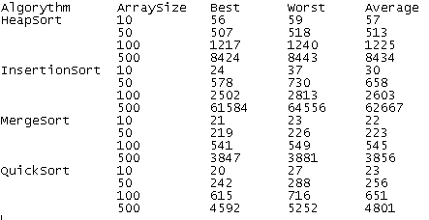
The quick sort worked the best on ten element data sets.
The merge sort worked the best on fifty, one hundred, and five hundred element data sets.
The merge sorted worked the best on average of on all the data sets.
The insertion sort preformed the worst on all data sets.

